Introduction to the basic version of LiGAPS-Dairy
Author: Aart van der Linden, Animal Production Systems group, Wageningen University & Research, the Netherlands (aart.vanderlinden@wur.nl).

1. Purpose of a basic version of LiGAPS-Dairy
The model LiGAPS-Dairy was calibrated and evaluated in the paper ‘Yield gap analysis in dairy production systems using the mechanistic model LiGAPS-Dairy’, which was published in Journal of Dairy Science. The source code of the model was published on the model portal of the Plant Production Systems group of Wageningen University & Research, the Netherlands (https://models.pps.wur.nl/models). This source code was used to generate results for the paper, and it contained multiple elements for model calibration and evaluation with measured data from experiments conducted in the Netherlands. As a consequence, the source code is not very user-friendly for readers in the paper that are interested in LiGAPS-Dairy. Moreover, the input data on feed quality and available feed quantity were property of Wageningen Livestock Research (part of Wageningen University & Research), and they could not be made available.
For these reasons, a basic version of LiGAPS-Dairy was created to show some features of the model and to provide some reproducible examples for those interested in the model. The source code of the basic version can be found in the file LiGAPSDairy 20210107 V1basic.R, which is available on the model portal of the Plant Production Systems group also.

2. Setting up the basic version
LiGAPS-Dairy can be opened in RStudio. The five input files required to run the basic version are ‘NLDLEL19912018_ext.csv’ (weather data), ‘Feedinput.csv’ (ideal diet under potential production), ‘Cow1.csv’ (diet cow 1), ‘Cow2.csv’ (diet cow 2) and ‘Input GHG module.csv’ (input parameters for calculation of GHG emissions).
Save the input files in a directory. Write the same directory for the weather data in line 280. Create a folder named ‘Feed’ in a directory and paste the files ‘Cow1.csv’ and ‘Cow2.csv’ in this folder. The directory of this folder should be written out in line 489. Insert the directory for the diet under potential production in line 502, and the line with input for GHG emission calculations in line 868. The standard directories in the original source code are ‘C:/R’ and ‘C:/R/Feed’, but these directories can be adjusted depending on the preferences of the model user.

3. Model simulations
Simulation 1: potential production of dairy cows in the Netherlands.
Check that POTENTIAL in line 100 equals 1, and that zseries in line 171 is a vector of c(1:1), and run the model. The average feed efficiency over the entire life span is 1.42 kg FPCM per kg DM feed, and the average milk production is 9885 kg FPCM per year (> 2 years of age), as indicated in the matrix OUTPUTHERDS1. The ‘ideal’ feed under potential production aims to eliminate any limitation in feed intake capacity and energy and protein deficiencies (Fig. 1).
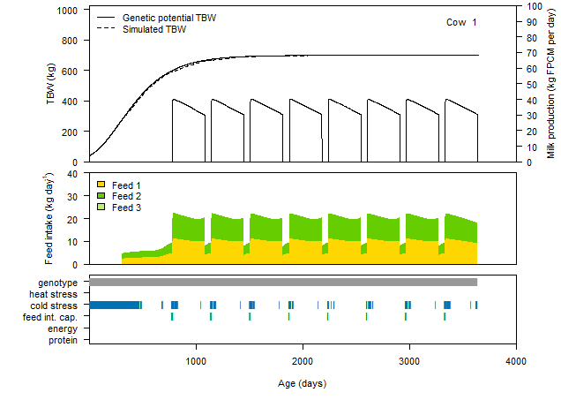
Figure 1. Model simulation of a Holstein-Friesian cow in the Netherlands under potential production.

Simulation 2: feed quality limited production of two dairy cows in the Netherlands.
Adjust the value of POTENTIAL to 0 in line 100. Adjust the value of FEEDQUALITY to 1 in line 103, and adjust the vector zseries to c(1:2) in line 171 to simulate two cows. Feeds are available ad libitum under feed quality limited production. We therefore use the maximum proportions of the three feeds in the diet. The value of the first FEED1fr in line 599 is 0.2, which means that feed 1 represents 20% of the diet. The value of the first FEED2fr in line 602 is 0.8, which means that feed 2 represents 80% of the diet. The data in ‘Cow1.csv’ and ‘Cow2.csv’ indicate that the feed available to cow 1 has a higher digestibility, but a lower protein content than the feed available to cow 2. The feed quantities available specified in both .csv files are not taken into account, because of ad libitum availability of feed under feed quality limited production. Run the model.
The lifetime feed efficiency of cow 1 is 1.25 kg FPCM per kg DM feed, and the average milk production is 9238 kg FPCM per year (> 2 years of age). For cow 2, the lifetime feed efficiency is 1.10 kg FPCM per kg DM feed, and the average milk production is 9046 kg FPCM per year. As expected from the feed input files, protein deficiency limits milk production of cow 1, and feed intake capacity limits milk production of cow 2 (Figs 2 and 3).
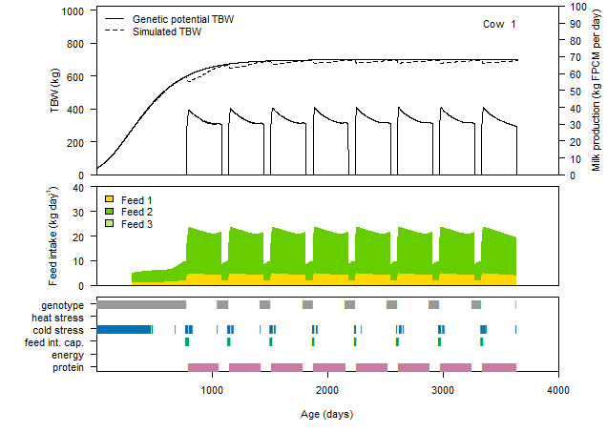
Figure 2. Model simulation of a Holstein-Friesian cow in the Netherlands under feed quality limited production (diet cow 1), where 20% of the diet is feed 1 and 80% of the diet is feed 2.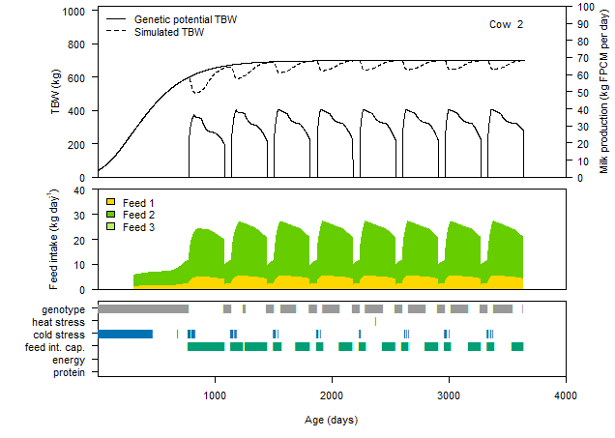
Figure 3. Model simulation of a Holstein-Friesian cow in the Netherlands under feed quality limited production (diet cow 2), where 20% of the diet is feed 1 and 80% of the diet is feed 2.
Simulation 3: feed quality limited production of two dairy cows in the Netherlands with fixed quantities of particular feeds.
Adjust the value of FEEDQUALITY in line 103 to 0. This adjustment means that the feed quantities available to the animals as specified in the files ‘Cow1.csv’ and ‘Cow2.csv’ are fed. The assumption is that the cows first consume feed 1, then feed 2, and if requirements are not met, feed 3. The quantity of feed 1 available to cow 1 after 2 years of ages (>730 days) is 3 kg DM per day in the file ‘Cow1.csv’, 10 kg DM per day for feed 2 and 50 kg DM per day or feed 3. Because the quantity of feed 3 is more than cows can consume, the feeding strategy is considered to be ad libitum. Run the model.
The lifetime feed efficiency of cow 1 is 1.16 kg FPCM per kg DM feed, and the average milk production is 8605 kg FPCM per year (> 2 years of age). For cow 2, the lifetime feed efficiency is 1.00 kg FPCM per kg DM feed, and the average milk production is 7976 kg FPCM per year. The results of these simulations show that the cows consume feeds 1 and 2 completely, and that feed 3 is consumed partly (Figs 4 and 5).

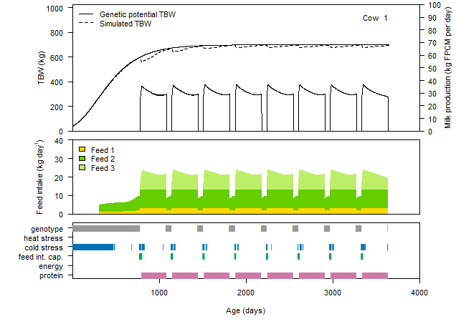
Figure 4. Model simulation of a Holstein-Friesian cow in the Netherlands under feed quality limited production (diet cow 1). Feed quantities available after 2 years are 3 kg DM per day for feed 1, 10 kg DM per day for feed 2 and 50 kg DM per day for feed 3.

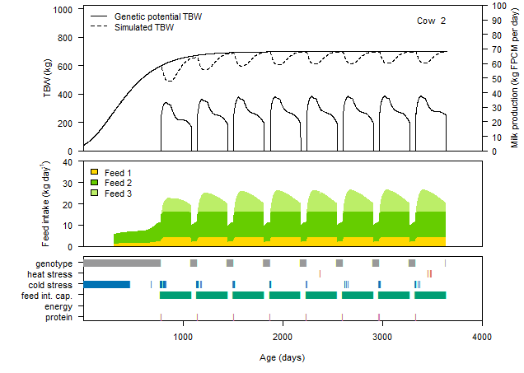
Figure 5. Model simulation of a Holstein-Friesian cow in the Netherlands under feed quality limited production (diet cow 2). Feed quantities available after 2 years are 4 kg DM per day for feed 1, 12 kg DM per day for feed 2 and 50 kg DM per day for feed 3.

Simulation 4: feed-limited production of two dairy cows in the Netherlands with fixed quantities.
Adjust the values in column ‘Feed3QNTY’ in the files ‘Cow1.csv’ and ‘Cow2.csv’ from 50 to 2 and save the files. Adjust the first FEED1fr in line 599 from 0.20 to 0.30, and run LiGAPS-Dairy.
The lifetime feed efficiency of cow 1 is 1.01 kg FPCM per kg DM feed, and the average milk production is 5407 kg FPCM per year (> 2 years of age). For cow 2, the lifetime feed efficiency is 0.90 kg FPCM per kg DM feed, and the average milk production is 5746 kg FPCM per year. The results of these simulations show that the cow consume feeds 1 and 2 completely, and that feed 3 is generally consumed completely also (Figs 6 and 7). Once the feeds are completely consumed, energy deficiency or protein deficiency occur due to the limited amount of feed available. In addition, feed efficiency and milk production decrease compared to simulation 3 where feed 3 was available ad libitum.

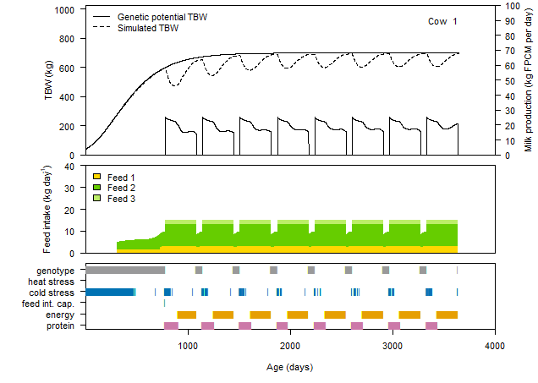
Figure 6. Model simulation of a Holstein-Friesian cow in the Netherlands under feed quality limited production (diet cow 1). Feed quantities available after 2 years are 3 kg DM per day for feed 1, 10 kg DM per day for feed 2 and 2 kg DM per day for feed 3.

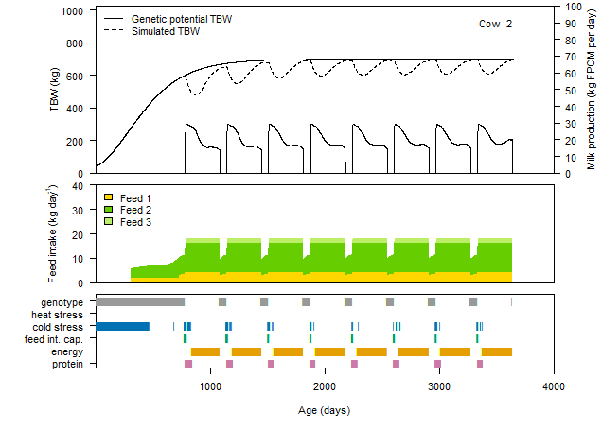
Figure 7. Model simulation of a Holstein-Friesian cow in the Netherlands under feed quality limited production (diet cow 2). Feed quantities available after 2 years are 4 kg DM per day for feed 1, 12 kg DM per day for feed 2 and 2 kg DM per day for feed 3.

Simulation 5: feed quality limited production of two dairy cows in the Netherlands with fixed quantities of particular feeds and improved genetics.
Adjust the value of the first FEED1fr back from 0.3 to 0.2 in line 599. Adjust the value of FEEDQUALITY back from 0 to 1 (ad libitum feeding) in line 103. Adjust the values in column ‘Feed3QNTY’ in the files ‘Cow1.csv’ and ‘Cow2.csv’ back from 2 to 50 and save the files. The genetic potential for milk production is described by Wood’s curve. The first parameter in Wood’s curve is the milk production at the start of the lactation. The parameter value for milk production at the start of the lactation is 30.85 kg per day, as indicated by the first value in line 379. Adjust this value to 35.00 kg per day and run the model. Increasing this number thus increases the genetic potential for milk production. Run the model.
The lifetime feed efficiency of cow 1 is 1.27 kg FPCM per kg DM feed, and the average milk production is 10120 kg FPCM per year (> 2 years of age). For cow 2, the lifetime feed efficiency is 1.10 kg FPCM per kg DM feed, and the average milk production is 9100 kg FPCM per year. As expected, milk production in this simulation is higher than in simulation 2 (without genetic improvement). Protein deficiency is the most limiting factor during large parts of the lactations for cow 1, because of the low protein content of the diet (Fig. 8). Feed intake capacity is the most limiting factor during large parts of the lactations for cow 2, because of the relatively low energy content of the diet that requires the cow to consume large amounts of feed (Fig. 9).

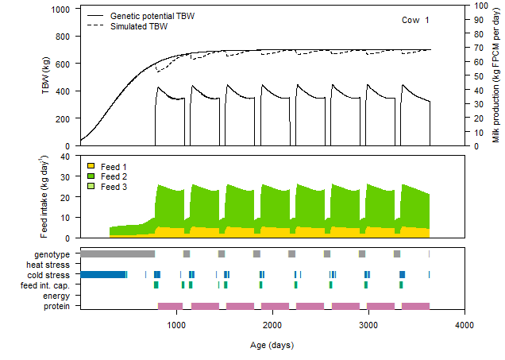
Figure 8. Model simulation of a Holstein-Friesian cow in the Netherlands under feed quality limited production (diet cow 1) with a higher genetic potential for milk production.
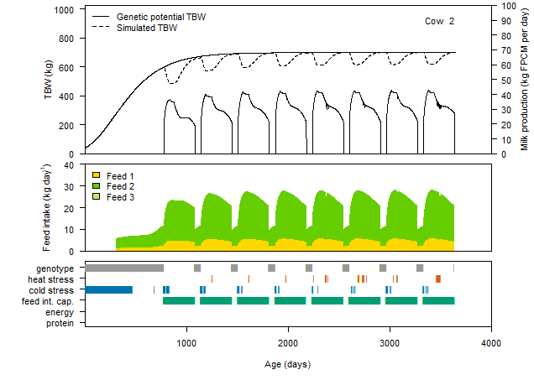
Figure 9. Model simulation of a Holstein-Friesian cow in the Netherlands under feed quality limited production (diet cow 2) with a higher genetic potential for milk production.

